Shady Tower

Project Proposal for Shady Asylum Theme Camp at Burningman 2005

A presentation of Shady Asylum.
Seattle, WA

Project Description

A public shade structure with live grass as a floor, in the shape of a pyramid with 60’ sides and 24’ feet tall. The structure is created by hanging 6 20x20 pieces of agricultural shade netting (weaved, 90% shade) off of three 20’ tall masts which will provide shade to the live grass flooring. Modular scaffolding will then be used to create a 15’ tall triangular tower in the center of the structure. This tower is 8’ on a side and supports the center pole to complete Shady Tower’s triangular top. Three 10’X10’ pieces of agricultural shade material are then hung from the center pole to the three masts, finishing the pyramid. Additionally, at 15’ the tower supports a platform, rated to hold over 15,000 pounds. This platform will also be floored in live grass and will provide a small place for meditation, contemplation, and viewing the playa from on high. Safety rails and the roof of Shady Towers both serve to restrict unsafe access to the platform’s edge, while portholes cut into the shade material will allow unrestricted gazing on BRC. The inner tower’s corners will also support a large hammock formed of cargo net, and furniture will again be buried under the grass to create social spaces. Additionally rope lighting will be strung along the steel rope to illuminate Shady Tower at night, and three floods inside Shady Tower will made nocturnal community more comfortable.

Specifications: A regular, triangular, pyramid with the top removed.

Sides = 60 ft.
P= 180 ft.
Slant Height (l)= 52ft
Apex Height = 24’
Lateral Area (LA) = 1/2P * l = 4680ft. sq.
Base Area (BA) = 1558 ft. sq.
Total Area (TA) = LA+BA= 6238 ft. sq.

Blueprints to scale before resizing for format

Shady Tower, top view
1” = 10” before scanning
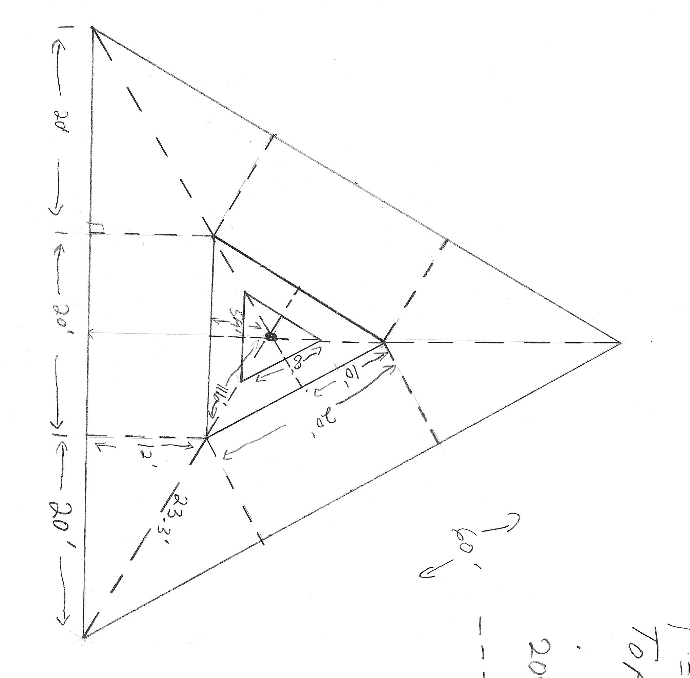
Shady Tower, Side View
1”=10’ before scanning
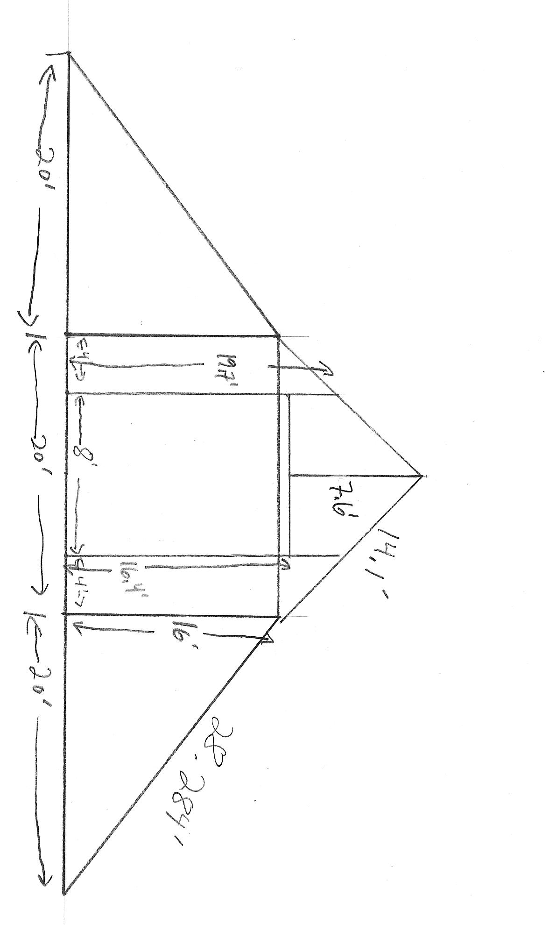

Scale Model(s)
External facing view
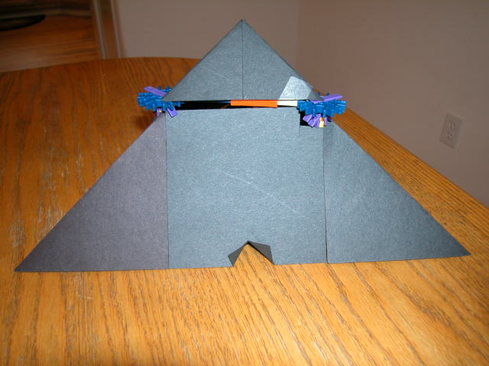

External side view
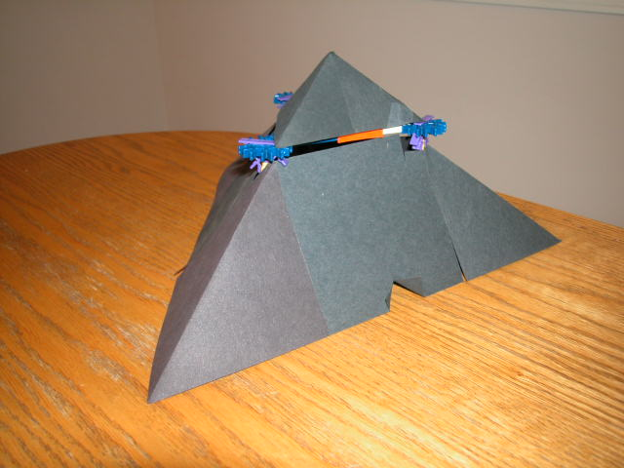

Internal Side View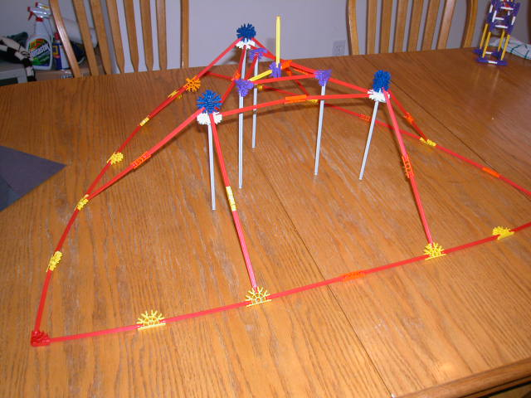

Materials List and Hours/Dollars Budget

Item | Person hours before playa | Set up hours on playa | Maintaince hours on playa | Strike hours on playa | Rental/purchase costs
6 20’x20’ black agricultural shade material to provide shade. | 2.5 | 1.5 | 3.5 | 2.5 | $950.00
3 10' Square black agricultural shade material to provide shaded | 2.5 | 1.5 | 3.5 | 2.5 | $175.00
3 x 20’ Steel Poles for center masts. | 30 | 3 | 1 | 5 | $0.00
2 20’ x 100’ Rolls Visqueen Plastic for underneath grass. | 1 | 1 | 0 | 1 | $40.00
3 20' steel wire lengths with loops on both ends | 1 | 1 | 1 | 1 | $0.00
3 28' steel rope with turnbuckle on one end, loop on other | 1 | 1 | 1 | 1 | $0.00
6 20' steel rope lengths with turnbuckle on one end, loop on other | 1 | 1 | 1 | 1 | $0.00
36 2’ spikes for anchoring Shade material to ground
3 2' Circus tent stakes
1700 square feet live turf. | 2 | 50 | 15 | 45 | $1,107.00
1500 gallons minimum water for purpose of keeping grass alive. | 0 | 1 | 2 |  | $600.00
1 2,000 gallon capacity pool for water storage | 1 | 1 | 7 | 0.5 | $300.00
1000’ heavy duty twine for multi purpose. | 1 |  |  |  | $0.00
Pre-trip construction | 80 | 0 |  |  | $50.00
Pre-trip packing up | 20
Shovel for cutting excess grass. | 1 |  |  |  | $0.00
1 Water pump | 0 | 0 | 1 | 0 | $0.00
Daily watering | 0 | 3 | 14 | 0 | $0.00
5000 square feet of muslin, canvas, or some other under root material | 5 | 1 | 0 | 3 | $300.00
Thousands of Zip ties | 1 | 0 | 0 | 2 | $30.00
3 steel disks with center holes, washers for poles | 3 | 0 | 0 | 1 | $50.00
1 20X100 clear plastic tarp for pool | 1 | 1 | 7 | 1 | $20.00
Misc. hardware, tools, etc. | 2 | 1 | 1 | 1 | $150.00
3 10' Square black agricultural shade material to provide shaded | 2.5 | 1.5 | 3.5 | 2.5 | $175.00
3 14' steel rope with loop on one end and turnbuckle on other for making upper triangle hyponusis | 2 | 1 | 7 | 1 | $25.00
6 7' steel rope with loop on one end and turnbuckle on other for cross bracing
1 8' by 8' by 8' triangular scaffolding tower | 10 | 5 | 7 | 2.5 | $150.00
One 7' mast mounted to scaffolding | 10 | 1 | 7 | 1 | $100.00
One 8' triangular custom built floor | 20 | 2 | 7 | 2 | $150.00
Extra plastic and muslin for under roots | 1 | 1 | 0 | 1 | $25.00
Total ShadyTower Cost | 157.5 | 69 | 57 | 67 | $3,687.00

Task List and Due dates

- Finish final design for platform 7/1
- Finalize rental of generator and scaffolding 7/15
- Finalize purchase of grass and water 7/15
- Purchase all needed material 7/8
- Find a staging location where we can build it before we go 7/10
- Build Shady Tower 7/23
- Modify plans based on building experience7/20
- Pack Shady Tower and head for the playa8/26
- Build Shady on Playa 8/28

